Jaden Martinez

1/30/2023

CS 470

Lab 3

1. How many child processes are created upon execution of this program?

**Three children processes are created upon execution of the program**

1. When you start a browser, you will notice the browser process appear in the top display. What does it consume?

**CPU and Memory.**

1. How much memory is available in the system?

**8308.7 MB available but have a total 9.06 GB**

1. Which process consumes the most CPU?

**PID 1556 gnome-+**

1. Which process has the most memory?

**PID 1556 gnome-+**

1. Could you please explain the following commands?

apt-get, yum, wget, gzip, tar, rar

**Apt-get**: is a command line interface for retrieval of packages and information about them from authenticated sources and for installation, upgrade, and removal of packages together with their dependencies.

**Yum**: is used to install, remove, and update packages from the terminal.

**Wget**: a command line to download files from the internet.

**Gzip**: compressed or uncompressed Files in Unix systems

**Tar**: saves many files together into a single tape or disk archive, and can restore individual files from the archive

**Rar:** proprietary file archiving utility for windows and Unix systems

1. Write a program that will generate a child process. In a loop, the child process

writes "I am a child process" 200 times and the parent process repeatedly

prints "I am a parent process" in a loop.

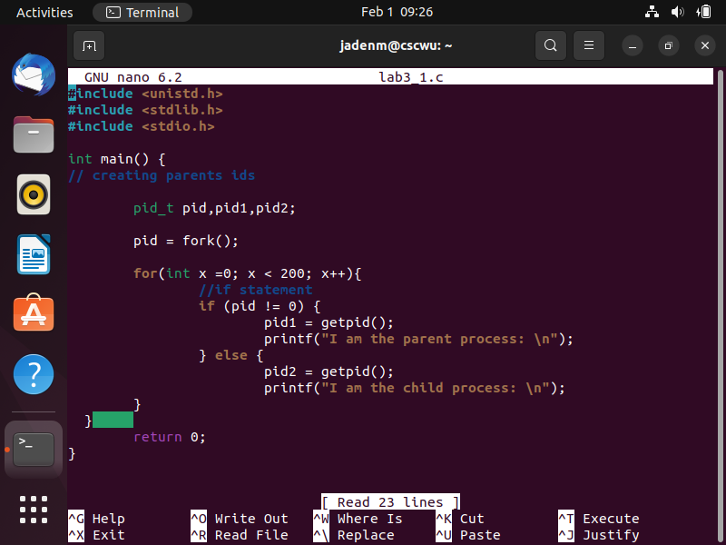



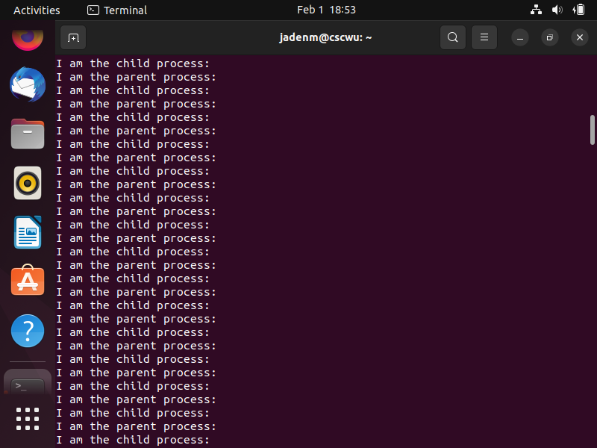

1. Write a program that create a child process with the fork () system call. The

parent process waits for the child process to finish before printing the contents

of the current directory.

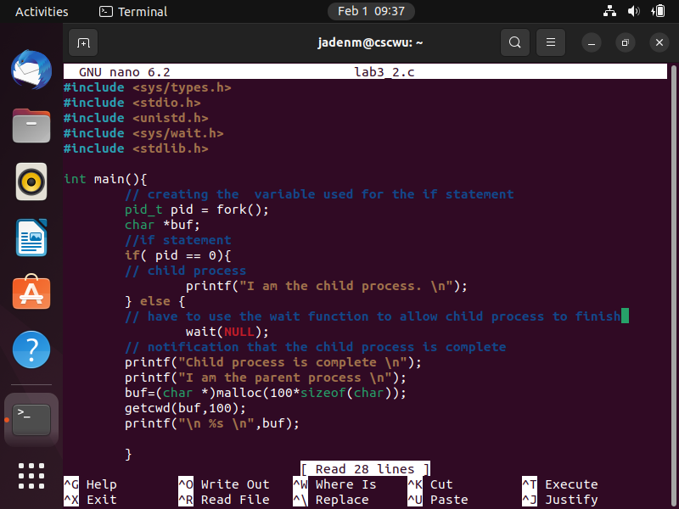

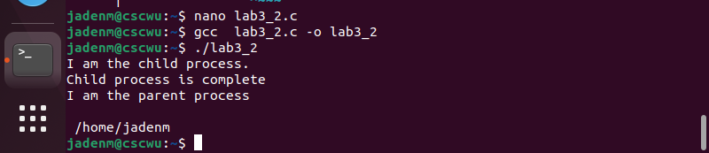

1. Write a program that create a child process with the fork () system call and

print its PID. Following a fork () system call, both parent and child processes

print their process type and PID. Additionally, the parent process prints the

PID of its child, and the child process prints the PID of its parent.

.

